**Live Converter User Guide**

**About The Program**

The program takes an input IP and Port and an output IP and Port, from the input it alters the stream in real time and sends the output as UDP packets to the destination specified

**Using The Program**

To run the program, from the command line in the directory containing the alterStream.py file, run with:

*python liveConverter.py “inputIP” inputPort “outputIP” outputPort*

From then, a series of integer based choices will be presented to the user, use the integer keys to select an option and enter to confirm.

**Program Flow**

* **Function Choice** choose whether the output is the complete stream with alterations, or just the alterations 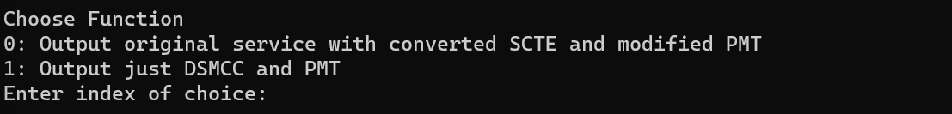
* **Null SCTE Choice** choose whether NULL SCTE are replaced with DSMCC or just a null packet

* **Service Choice** choose the service 
* **Multiple Service Choice** where, if yes, the service choice option will come up again, this can be repeated for as many services as requiredA black background with small dots

  Description automatically generated
* **Outputs** will be shown where relevant (when an altered PMT / DSMCC is inserted) A black background with white text

  Description automatically generated